**Final Project Report**

**Yiwei Wu**

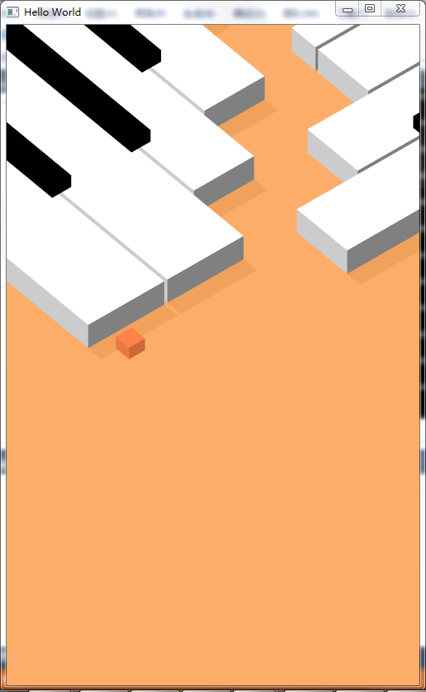

The scene is rendered in two pass. In the First Path, treat the light position as camera to render the scene, and bind the result to a texture using framebuffer. And then render the scene again using that texture.

I designed the paths. The positions of the piano blocks and the running line are computed and output in a file. I use an element buffer to draw all the blocks..

To start the game, click on the screen, the block on the screen will get down to the floor. And press the mouse again to run the block.

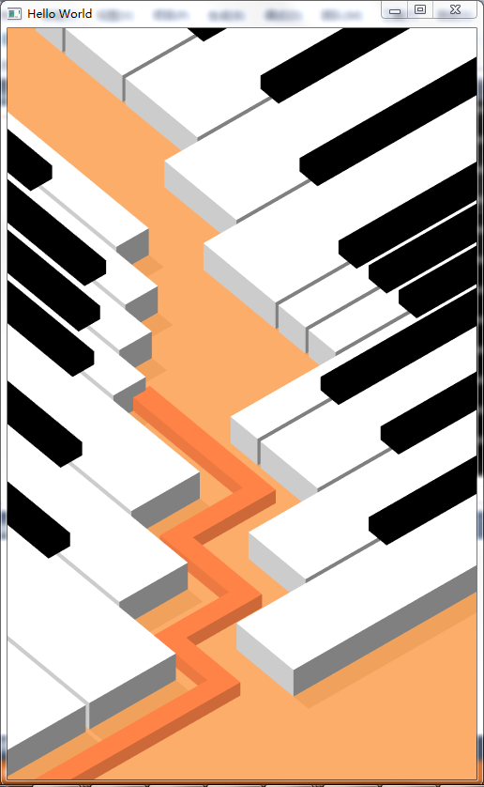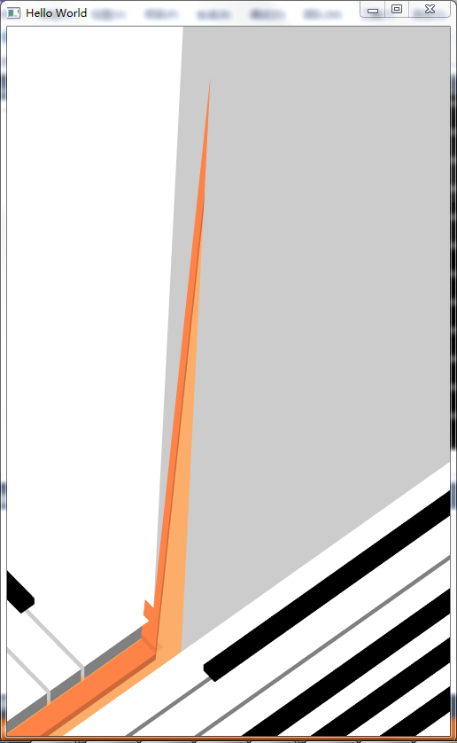

When the line hit the piano block, the moving stops, and a hitting sound occurs as a sign of failure. Click on the screen to restart the game.

If the line successfully goes to the end, the camera will move up. Click on the screen this time will also restart the game, moving the camera and block back to the original place.